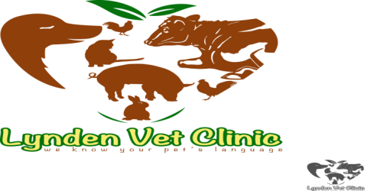
Lynden Veterinary Clinic
Kony House, Ngong Road,
Off Karen near Zambia Stage
P.O. Box 61433-00200
Nairobi, Kenya
E-MAIL: lyndenvetclinic@gmail.com
Tel: 0202402588
Cell: 0721263135/0721440966
________________________________________________________________________________
HEALTH CERTIFICATE/MOVEMENT PERMIT

DATE: …………………………

This is to ascertain that on ……………. I examined the dog whose details are described below, and found them free from any external and internal parasite and or signs/symptoms of any infectious disease. The dogs have been dewormed and are fully vaccinated against Canine Distemper, Hepatitis, Leptospirosis, Para-influenza and Parvovirus and Rabies as indicated in the accompanying vaccination certificates.

OWNER’S DETAILS
Name : Felix Otieno Oduor
Postal address : Ngong Road
Contacts : 0797 754 596

PETS PARTICULARS
Name : Coffee and Beans
Species : Canine
Breed : Cross
Colour : Brown

As such the dogs are free to travel from Nairobi to Rongo by Road.

Yours sincerely,
Dr. Jared K. Ombasa
KVB NO. 2431

