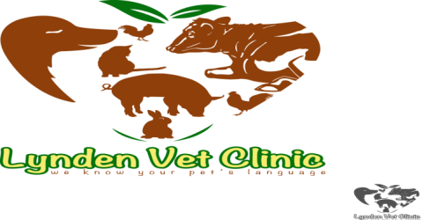
Lynden Veterinary Clinic
Kony House, Ngong Road,
Off Karen near Zambia Stage
P.O. Box 61433-00200
Nairobi, Kenya
E-MAIL: lyndenvetclinic@gmail.com
Tel: 0202402588
Cell: 0721263135/0721440966
________________________________________________________________________________
EXAMINATION FORM

Date…………………. Pet Name……………………… Complaint……………….…………
PARAMETERS
Weight………………………………………………………………………………………………..
Temperature………………………………………………………………………………………..
Mucous Membrane………………………………………………………………………………..
Heart Rate…………………………………………………………………………………………..
Reinvation Rate…………………………………………………………………………………….
Demeanor……………………………………………………………………………………………
Hair Coat/Skin…………………………………………………………………………………….
Gait……………………………………………………………………………………………………
Others………………………………………………..………………………………………………
DIFFERENTIAL DIAGNOSIS

SAMPLES TAKEN

RESULTS

DIAGNOSIS

TREATMENT

RECOMMENDATIONS VET DR/CLINICIAN

