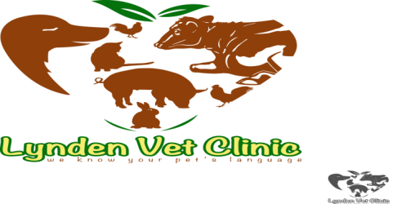
Lynden Veterinary Clinic
Kony House, Ngong Road,
Off Karen near Zambia Stage
P.O. Box 61433-00200
Nairobi, Kenya
E-MAIL: lyndenvetclinic@gmail.com
Tel: 0202402588
Cell: 0721263135/0721440966
________________________________________________________________________________
BOARDING CHECK-IN FORM
Owner Name:_____________________________________ Pet Name:________________________
Date of drop off:___________________________ _______Date of pick up:__________________
I understand my pet must be current on vaccinations to board. If proof of vaccinations is not presented at the time of boarding, the vaccinations will be given, and I will be charged of these services. I my pet become ill or an emergency arises, I authorize Lynden Vet Clinic to perform the diagnostics and treatment medically necessary/for the health and comfort of my pet during Boarding. If the charges for these services exceed Kshs.4000.00, every attempt will be made to contact me. However, services will not be withheld if I am unreachable. For charges less than Kshs.4000.00, NO attempt to contact me will be made. I will be financially responsible for the services rendered.

Please perform the following procedures while my pet is boarding. Charges for these services will be added to the boarding fees.

___________________________________________________________________________________________________________
Please list any medications and heartworm preventative your pet will need while boarding.
DRUG DOSAGE TIMES per DAY BROUGHT MEDICINE (Y/N)
________________________________________________________________________________________________

Please be especially aware of these problems: ______________________________________________________________
Please note that your pet will be bathed prior to being released from the kennel? (Charge is Kshs.1000.00)

Feeding instruction: Dry________________________________________________ (how much/how often)
Canned ___________________________________________ (how much/how often)
Type of food_______________________________________

WE WILL NOT BE HELD RESPONSIBLE FOR ANY ITEMS LEFT WITH YOUR PET, PLEASE UNDERSTAND THAT ANYTHING YOU LEAVE MAY NOT BE RETURNED TO YOU. WE ENCOURAGE YOU TO TAKE ALL PERSONAL ITEMS WITH YOU, INCLUDING LEASHES, COLLARS, TOYS AND CARRIERS.

IN AN EMERGENCY, PLEASE CALL: (We must have your number or a responsible contact person)
Name: ________________________________________________ Phone: ________________________
Name: ___________________________________________ _______ Phone: ________________________
________________________________________________________________________________________________
My pet will be picked up on_____________________________ at approximately ________am _______pm

Failure to collect the animals 30days from the above date, Lynden Veterinary Clinic will rehome or dispose the dog/cat to recover costs incurred. Signing this form acknowledges that I have read and understand all of the above information and agree to the above terms.

Deposit paid: _________________
_______________________________ _______________________________
Signature of Owner/Responsible Agent Lynden Veterinary Clinic Attendant

