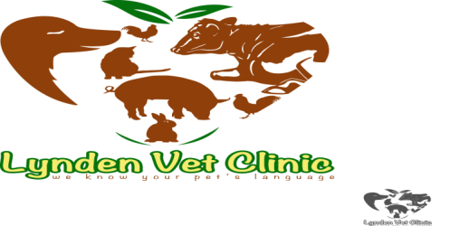
Lynden Veterinary Clinic
Kony House, Ngong Road,
Off Karen near Zambia Stage
P.O. Box 61433-00200
Nairobi, Kenya
E-MAIL: lyndenvetclinic@gmail.com
Tel: 0202402588
Cell: 0721263135/0721440966
________________________________________________________________________________
SURGERY CONSENT FORM

Surgical Procedure:…………………………………………………………………………..…
Client Details | Name:…………………………………………………………………..……………  Contacts:………………………………………………………………………….  Address:…………………………………………………………………..………..
Patient Details | Name:……………………………………………………………………………..  Breed:……………………………………………………………………….…….  Species:…………………………………………………………………..………  Age:………………………………………………………………………..………  Sex:………………………………………………………………………………..  Color:………………………………………………………………………………..

Declaration
I……………………………………………………………………………… of the above address being over the age of eighteen (18) years hereby give my consent to the provision of surgery by a register veterinary surgery on the animal whose details appear above
Signed:………………………………………………………………………………..

This………………………………. Day of………………………….20……………

